Speech by

ADAM S. POSEN1

EXTERNAL MEMBER, MONETARY POLICY COMMITTEE, BANK OF ENGLAND AND SENIOR FELLOW, PETERSON INSTITUTE FOR INTERNATIONAL ECONOMICS

# THE CASE FOR DOING MORE

Speech to the Hull and Humber Chamber of Commerce, Industry and Shipping KC Stadium, Hull

28 September 2010

1 I would like to thank - without implicating - my colleagues on the MPC, as well as Joe Gagnon, Tomas Hellebrandt, Ken Kang, Ken Kuttner, Kiyohiko Nishimura, Larry Meyer, Neil Meads, Ryuzo Miyao, Mike Prell, Angel Ubide, Kazuo Ueda, Andrew Wardlow, and Tony Yates for ongoing discussion of these issues. I am also grateful to the Alfred P. Sloan Foundation for its support of my long-term research on exit strategies and financial restructuring. The views expressed here are solely my own, and not those of the MPC, the Bank, PIIE, or of Sloan.

# THE CASE FOR DOING MORE

**Adam S. Posen**

I am grateful for the opportunity to be with you at KC Stadium today, here in Hull. Members of the Bank’s Monetary Policy Committee [MPC] are committed to getting a sense of the UK economy and its future from ongoing dialogue with business and working people all over the country. The relationships between the British Chambers of Commerce and the Bank’s regional Agents make a huge contribution to enabling that two-way discourse. It has been my privilege over the last year to have been hosted by your fellow chamber members in Glasgow and Skegness, Durham and Dagenham, Edinburgh and at a general BCC meeting in London. My regular interaction with local Chambers is all part of the MPC’s efforts to be open to new ideas and information, and open about what it is thinking.

In that spirit, today I want to give my own view on the role of monetary policy in our recovery, and whether the major central banks in the UK and beyond should be doing more in the coming months. Of course, every central bank’s policy-setting committee has to make its own assessment of the right policy measures for its economy, based on its own forecast and the mandate legally set for it. Thus, I am not presuming to offer a one-size fits all prescription for central bankers beyond the United Kingdom. I would like, however, to try to give some general assessment of the common challenges we face, and what I believe to be the appropriate monetary policy response, barring special circumstances. Not that there will be any doubt about it, but for the record, these are solely my own personal views.

The case I wish to make is that monetary policy should continue to be aggressive about promoting recovery, and, subject to further debate, I think further easing should be undertaken. To some, that will sound obvious or even overdue. To others, that will sound moot, given the measures already taken and the assumption that there will be diminishing effectiveness of further central bank actions. To still others, this is a call that for actions that are dangerous to price

stability, central bank independence or fiscal discipline.2 So this is an open debate, at least for those with open minds. What I would like to argue today is that policymakers face a clear and sustained uphill battle, in which monetary ease has an ongoing role to play, even if it may not deliver the desired sustained recovery on its own. In every major country, actual output has fallen so much versus where trend growth would have put us, and trend growth has not been above potential for long enough as yet, that there remains a significant gap between what the economy could be producing at full employment and it currently produces. Thus, policymakers should not settle for weak growth out of misplaced fear of inflation. If price stability is at risk over the medium-term, meaning over the two- to three-year time-horizon for the MPC’s decisions, it is on the downside.

There are, however, some very serious risks if we make policy errors by tightening prematurely, or even if we loosen insufficiently. Those risks are not primarily the potential for a double-dip recession or even of temporary measured deflation. While bad, those situations would still be within the range of short-term cyclical developments, and could be weighed against simple inflationary pressures from monetary policy trying to stimulate too much. The risks that I believe we face now are the far more serious ones of sustained low growth turning into a self- fulfilling prophecy, and/or inducing a political reaction that could undermine our long-run stability and prosperity.3 Inaction by central banks could ratify decisions both by businesses to lastingly shrink the economy’s productive capacity, and by investors to avoid risk and prefer cash. Those tendencies are already present, and insufficient monetary response is likely to worsen them. The combination of those risks with the potential attainable gains motivates my call for additional monetary policy stimulus.4

This view is based on my reading of historical comparisons and cross-national evidence (including but extending far beyond my own research). Such an assessment does not hinge on a specific interpretation of any particular recent data, let alone of new information suggesting an

2 Examples of the first camp would include Gagnon (2009) and Krugman (2010a), of the second camp Oda and Ueda (2005) and Shiratsuka (2009), and of the third camp, most of the contributors to Wall Street Journal (2010). 3 On this potential for political backlash, see Alderman (2010), Dao and Loungani (2010), O’Rourke (2010) and

Posen (2005).

4 Where consistent with local conditions and central bank mandates. In the UK, as I will discuss, the case is clear.

imminent double-dip in the UK or elsewhere. My assessment instead rests upon the path of post- crisis developments having been broadly consistent with these past patterns as seen in Japan in the 1990s and in the United States and Europe in the 1930s: economic recovery following a financial crisis is a long process dominated by the interaction of unemployed resources, dysfunctional banking systems, and the degree of policy stimulus. We are a long way from home, and a long, long way from overheating.

The absence of any recent data inconsistent with this pattern in the UK or elsewhere in the West seems to me pretty conclusive. If there was going to be a recovery that either was inflationary or otherwise meaningfully different from that established pattern, it should have been evident by now. Instead, we have seen global interest rates on long government bonds, determined by forward-looking markets, at historic lows. Absent evidence of a truly different recovery, the analysis of mainstream macroeconomics should apply, as it did in Japan in the 1990s and in the US and Europe in the 1930s. That proven analysis tells us that, under the present circumstances, sustained high inflation is not a threat, that persistent high unemployment and output gaps are the threat, and we should take further monetary action to sustain and promote recovery. As in the usual post-crisis bad recovery scenario, there will be a long-period of ups and downs, also seen in Japan’s Great Recession and during the Great Depression – those short-term fluctuations are not what I think central banks should focus on. The case for doing more is about activism for sustaining a period of recovery from a low point, thereby preventing us from getting stuck in a long-term trap. The challenge for monetary policy today is not about fine-tuning developments in prices and output.

My intent today is to advance debate about this issue, both public debate and discussion within the MPC. I am hopeful that my remarks will elicit strong commentary from the informed public

- I know it will from my colleagues at the Bank. We do actually listen to each other and deliberate within the MPC at every monthly meeting. So I am very open to arguments coming to me through that discussion, as well as through public comment, that will cause me to think about things differently, just as I hope my arguments might lead others to think freshly. As a result, no one in the markets or the press should take my vote at next week's MPC meeting as a foregone

conclusion. If it were, there would be no reason for me to set out my arguments as I am for your scrutiny here today.

# Why central banks should do more –

When I parachuted into the debate over Japan’s Great Recession some years ago (Posen (1998)), my working assumption was that the problem was amenable to good old fashioned – some would say Keynesian – macroeconomics. The field of policy relevant macroeconomics had emerged out of the Great Depression which bore some profound similarities to the situation in Japan.

This view has since been borne out by subsequent research.5 The source of interest was and is whether Japan’s situation could happen to any economy, given the right set of shocks and the wrong set of policy decisions. I argued that it could, and now we are all trying to avoid that outcome for our own economies. A key implication of this analysis is that there was no single decisive event that locked Japan into its fate. Neither the bubble bursting nor the mounting debt on household or corporate balance sheets nor even the initial slow reactions of Japanese fiscal and monetary policy to the crisis made years of stagnation inevitable. The picture was instead of nascent recoveries being aborted first by macroeconomic policy mistakes, and then by the weight of financial problems accumulated over that slow and volatile growth path.

People familiar with the history of the real Great Depression in the US and Europe will recognize the parallels. The Great Depression was not simply set in motion on one day, even if there were dramatic triggering panics in 1929. Various asset price crashes in the 1920s and 1930s, bank runs and financial fragility, fitful recoveries, sequences of policy mistakes regarding late exits from the gold standard and budgetary austerity, and ruinous global trade and exchange rate conflicts (thankfully absent in Japan in the 1990s and so far today) all cumulated into a prolonged terrible period. The Great Depression was not caused by a single shock or policy mistake, and it was not over quickly. Some extremely useful recent cross-national research has

5 See Posen (2010a) and the references therein.

established that in broad terms the same pattern of persistently slow and choppy recovery following financial crises holds for a wide range of economies in the postwar period as well.6

What drove many of the economic policy mistakes in Japan, particularly on the monetary side, was repeated underestimation of Japan’s potential growth.7 Similar mistakes played a contributing role in the harmful actions of the major central banks in the 1930s. (Ahamed (2009)) For monetary policymakers, the estimate of the potential of the economy to grow on average without inflation matters, because when an economy’s growth rate exceeds potential – aggregate demand is too high - and the economy is already running close to capacity, inflation is the result, as seen in the 1970s.8 When a central bank underestimates how fast an economy can run without causing inflation, however, or how far away an economy is from full employment, it can cause slow growth and even recession or deflation. There is no getting away for central banks from having to make this assessment of something directly unobservable, and there is no virtue to getting it wrong in either direction.

This medium-term ‘Phillips Curve’ relationship between output and inflation is supported by a robust set of results renewed in the empirical literature at intervals.9 Thus, it is no surprise that in the aftermath of a financial crisis, the general tendency is for sustained downward pressure on inflation.10 Outright deflation emerges only rarely, largely because of the resistance to nominal wage declines by both workers and businesses (which means the unemployment rate is higher in

6 Notably, Abiad, et al (2009), Claessens, et al (2009), Meier (2010), and Reinhart and Reinhart (2010) are very relevant and persuasive contributions to this literature of cross-national post-crisis studies.

7 See Posen (1998, 2001, 2010b). The original working title of my first book on Japan was ‘How Much is Enough

for Japan?’ to highlight the key role of this repeated underestimation in what kept Japan from recovering.

8 There are other factors affecting inflation besides the gap between aggregate supply and demand. In the short-term

of less than a year, price shocks like exchange rate movements or oil price increases affect inflation outcomes. In the long-term of more than a few years, the credibility of the central bank’s commitment to price stability and of the government to fiscal discipline matter. But the gap between supply and demand is the primary determinant of inflation over the time-horizon that monetary policy decisions influence, i.e., two- to three years ahead.

9 Among others, see Ball and Moffitt (2001), Fuhrer and Olivei (2010), and the large body of Robert J. Gordon’s

work on this topic.

10 Variations on estimated Phillips Curve relationships between output or unemployment and inflation continue to

apply in these situations. Meier (2010) finds a consistent pattern of downwards pressure on inflation in his sample of post crisis economies; Liu and Rudebusch (2010) and Stock and Watson (2009, 2010) demonstrate this for the US using sophisticated methods; Posen (2010b) shows that even relatively simple Phillips Curves fit the inflation data for the largest economies in the current crisis - except for the UK, but that result is distorted by one-time transient shocks, as I discuss below (see also Dale (2010b) and Fisher (2010) regarding the UK inflation experience of late).

times of low inflation or deflation than the usual Phillips Curve trade-off would imply).11 Krugman’s (1998) justly famous liquidity trap model shows the possibility of similar perverse effects in financial markets when low or negative inflation expectations become entrenched, but the nominal interest rate cannot be cut below zero. These perversities of low inflation or deflationary environments exacerbate the real economic harm of the situation – they do not counteract the downward pressure on prices simply because instead of measured deflation the economy sees real dislocations.

Even in normal times, central banks cannot simply read-off from a pre-crisis Phillips Curve, or from the level of observed output, employment, and inflation, directives on what policy to pursue, let alone what outcome to choose (the mistake of the early 1970s). After a financial crisis, with inflation low and deflation looming, it is even less direct. Kuttner and Posen (2004) document the unreliability of output gap estimates, and thus of strict guidance from Taylor rules for monetary policy, in Japan in the 1990s due to the low inflation environment. These should be taken as cautions against fine-tuning by monetary policymakers, however, and though important, still support the big picture of basic macroeconomics applying in the current situation: times of low demand and idled factors of production lead to downward pressure on prices. This is how I would characterize the reality that Krugman (2010b) channeling Tolkien has called “One Model to Rule Them All.” None of these results support the idea that ongoing rises in inflation could emerge from such a situation as we now find ourselves in.12 As I discuss below, the current overshooting of the UK’s inflation target is not going to be sustained for long, largely because this downward pressure is kicking in, and that outweighs the lingering impact of forecast errors we at the Bank made previously.

11 These kind of effects of low inflation on labor markets are formally modelled in Akerlof, Dickens, and Perry (2001). Kimura and Ueda (2001) and Kurota and Yamamoto (2003) show how these effects came into play in Japan during the 1990s. As noted by Smets (2010), discussing Stock and Watson (2010), nominal wage rigidities can be seen playing a role in the current crisis as well.

12 No, I am not denying the current existence of large government debt stocks, nor the historical proclivity for some

indebted governments to inflate some of that debt away. Absent political upheaval fundamentally delegitimizing tax collection and public spending decisions, however, those pressures are not relevant to our developed democracies with independent central banks, open capital accounts, and free bond markets.

How big a mistake could central banks make in underestimating potential growth? Consider figures 1 and 2, which show various computations of trend growth rates for Japan and the UK respectively. In Japan, official estimates of potential growth were as low as 0.5% real year-over- year during the 1990s (Posen (1998, 2001)), and partly as a result, the Bank of Japan hesitated to aggressively ease policy, and then hesitated to undertake unconventional stimulus. Yet Japanese output growth in the 1990s, excluding the end of the boom, averaged more than twice that rate a year, coincident with outright deflation. When the Japanese economy recovered from end of 2002 to mid-2008, it averaged more than 2.0% real annual growth, and prices took almost the entire period of that recovery to begin to rise. Whatever damage to potential output was done by the crisis, whatever lasting loss of productive capacity Japan suffered, was not enough to offset the downward pressures of underutilized resources. Clearly, the inflation threat of overheating was much exaggerated, and as a result the Japanese people suffered a lost decade of employment and growth.

What about in the UK today? As shown in figure 2, the difference between UK GDP growth rates during the boom of the 2000s and on average in the more normal 1990s is meaningful, but much smaller than was in Japan before and after the bubble, i.e., less than half a percent annually. That relatively small difference suggests that the extent to which the UK was growing above potential if any prior to the crisis was small, since a small improvement in potential is more credible than a big jump. Saying that the UK was close to potential in the 2000s is of course consistent with the stable low inflation outcomes enjoyed until 2008. By including the awful experience of the crisis, we could drive down the average of real GDP growth rate since 2000 by a full percentage point a year, to 1.65%. If one were to mistakenly do so, meaning one takes the growth rate of the last two years, from the 2008:Q3 to latest available data, as representing a fundamental shift in the UK’s potential, and/or one were to assume that the crisis somehow directly destroyed a lot of UK productive capacity (instead of leaving it idle, and over time decaying), then one could become concerned about recent good quarterly outcomes causing inflation going forward.

But there is no good reason to make that assumption, at least not to the degree that would lead one to believe we are already close to full capacity or growing well above sustainable trend.

Mistaking the immediate impact of a financial crisis for a fundamental decline is precisely the error that was made by monetary policymakers in Japan in the 1990s, and elsewhere in the 1930s, and could be devastating here today. This is my take from Governor King’s famous comment that, after the crisis, “It’s the levels, stupid,” that count primarily for the inflation forecast (Bank of England (2009)). Recently, my MPC colleague Spencer Dale (2010b) has re- emphasized that the fact that UK output is now 10% lower than it would otherwise have been, absent the crisis, a number far in excess of even the most pessimistic estimates of decline in UK supply capacity.

There has been a negative impact on the supply side of the UK and other economies due to the crisis, and I do not dismiss it. In fact, I am on record forecasting that aggregate supply and trend productivity – that is the determinants of potential output going forward over a central bank’s time horizon – will be noticeably damaged by the crisis, including in the United States. (Posen (2009b,c)). There is no contradiction between recognizing this reality and also making the assessment that the *immediate* fall in output and employment after the 2008 panic was far larger than the contraction to date in productive capacity. That is the logical outcome because, as I have put it in Posen (2010a) and elsewhere, the workforces of the advanced economies did not wake up one morning and find that their left arms and their places of work both had disappeared overnight.13 That leaves for now large output gaps of underemployed resources pushing down on inflation.

Yet, the longer that growth remains below potential and that output gaps persist, the more lasting damage is done to our economic potential and to our citizens.14 . That is why I emphasized the word ‘immediate’ when talking about the relatively larger impact of the crisis on aggregate demand than aggregate supply. The classic and all too relevant channel through which lasting damage to productive capabilities occurs is the process whereby people laid off from work

13 We know that such things can happen, and have happened, through war, and we should recognize that, unlike too many in the world today and too many of our grandparents, we are fortunate not to be experiencing that horror.

14 Dickens and Madrick (2010) give a review of recent some theory and evidence on this interaction.

during a recession have few options, those unemployed then become long-term unemployed and de facto unemployable over time.15 In the US, there is increasing evidence of structural mismatches in the labor market and of a rise in the share of long-term unemployment (and leaving the labor force) among working age adults; in fact, the US seems to be on a path towards channeling the EU unemployment experience of the 1980s.16 And while many European economies, most strikingly Germany but also including the UK, have not seen such large rises in unemployment in response to the initial shock as in the US, these problems are still emerging.

(Guichard and Rusticelli (2010) Of course, for Greece, Ireland, Spain, and some others, risks of hysteresis reinforcing already high long-term unemployment are out in full force.

One should make the same kind of arguments regarding other factors of production than labour, meaning business equipment and corporate finance. My MPC colleagues and I have spoken in our last few *Inflation Reports* and meeting minutes about the macroeconomic impact of temporary idling by businesses of, say, one production line in a plant (or one line of service in an consultancy) and of the associated skilled workers (e.g., Bank of England (2010, p. 26)). In a speech earlier this year, Deputy Governor Tucker (2010) summarized this negative dynamic:

“In the months after the Lehman crisis, the cutbacks in lending and in trade credit insurance were so severe that some firms were probably unable to maintain production at previous levels. Working capital is, after all, an intermediate input [to production].

Those constraints have probably reduced over the months. But, given insipid and uncertain demand, not a few firms seem to have temporarily suspended part of their capacity: whether by putting part of their workforce on short hours or closing down a production line. This makes it likely that supply conditions are going to depend heavily on the path of aggregate demand...[if] demand proves anaemic, then suspended capacity is more likely to be permanently scrapped...”

15 Economists call this effect on unemployment “hysteresis”, following Blanchard and Summers (1986). Ball (2009) and Dao and Loungani (2010) give recent takes on the continuing relevance of this concern.

16 My PIIE colleague Jacob Kirkegaard (2009) was ahead of the curve in identifying this development. Altig (2010)

gives a good summary of recent data on mismatch. See also OECD (2010) and BOJ Board Member Miyao’s comments (Ujikane (2010)). This raises some questions about labor market institutions for future research

As the businesspeople in this audience will recognize, if sufficient demand comes back in time, it is both feasible and profitable for companies to reactivate those machines and workers; if not, it becomes inevitable for those lines to be closed down and those workers to be let go. If the capacity and workers are brought back on line in time, additional aggregate demand will not be as inflationary as it normally would be, because capacity will increase. Once the mothballing becomes permanent, however, then inflation responds more quickly to growth in demand, given the lasting reduction in the economy’s productive capacity.

This is more than a plausible theory or collection of anecdotes about short-term feedback loops. Banking systems which are left undercapitalized or otherwise impaired tend to rollover outstanding loans to larger borrowers and to undersupply credit to new firms and smaller enterprises during recessions. The banks’ idea is to avoid declaring large losses so present management can retain their jobs. The upshot of persistent recession interacting with such bank incentives to limit lending, however, is also to reduce growth in employment and in productivity. Japan showed clear signs over the course of its lost decade of diminishing corporate competition and innovation due to credit market dysfunction.17 Economic researchers Aghion, et al (2009) and Ouyong (2010) establish across countries over time that R&D investment at the firm-level suffers asymmetrically in recessions and periods of financial disruption – and lower investment in innovation of course has a significant negative impact on long-term growth.

Of course, this adverse outcome for trend growth and productive capacity is only inevitable in the aggregate, because these effects are not the only processes at work following a financially- induced recessionary shock. Some individual businesses do increase efficiency during recessions by becoming leaner and meaner. Field (2006, 2009) establishes that the US actually had significant productivity growth during much of the 1930s. As I argued in Posen (2001), Japan undertook meaningful structural reform of communications, energy, financial, retail, and, to a lesser degree, labor markets during its lost decade, which kept the potential growth rate there

17 See Caballero, Hoshi, and Kashyap (2008), Hoshi and Kashyap (2004), Shimizu (2000), Posen (2009a, 2010a), Aghion, et al (2009), and the references therein.

from falling as well. But we must note that such reforms increased the output gap until growth kicked in, and still left unemployment high and inflation low or absent. In addition, as Eichengreen (2010) points out for the US in the 1930s, and as I would agree also holds regarding Japan in the 1990s, the productivity improvements seen were the result of a multitude of policy decisions and business choices taking place against the weight of very evident negative pressures of the sort I have discussed. The only inevitable aggregate supply effects of protracted recessions are the negative ones, and more positive productivity developments require sustained effort from businesses and governments.18 This is another reason why it is right to characterize post-crisis periods as long struggles with ongoing demands on macroeconomic policy.

Central bankers have been leery about drawing links between monetary stimulus and long-term supply for thirty-plus years. We fear repeating the mistakes of the 1970s, when central bankers overestimated potential growth and overheated our economies, causing high inflation. We internalized the insights of Nobel Laureates Milton Friedman and Edmund Phelps on the independence of the natural rate of unemployment from inflation expectations (i.e., the long-run Phillips Curve is vertical). We are wary of making politically dangerous or populist promises with regard to employment, since printing money cannot create jobs in normal circumstances, but the demand for so doing is always there. As a result of these concerns, many central banks have adopted price-stability focused mandates as a bulwark against making policies on the basis of such a link between short-term monetary stimulus and sustainable growth.

I believe, however, that central bankers’ fears on this score can be taken to intellectually unjustified extremes, and there is a risk of our doing so now when the damage could be great by so doing. When the overwhelming bulk of pressures in the economy are disinflationary, and when the level of output and employment is clearly likely to be below potential for an extended period, it is right for central bankers to take the additional negative effects of protracted recession on trend productivity growth and on capacity into account. That is a far cry from 1960s and 1970s monetary policy efforts to push the economy into growth without regard for the limits on,

18 Posen (1998, ch. 6) summarizes the literature on why recessions are inefficient and do not automatically cleanse the economy in a productive manner. I will spare the audience rehashing this debate.

and in fact the decline then in, potential growth. To the degree that monetary policymakers have a choice about how we maintain price stability, we should always prefer getting inflation back from below target by offsetting insufficient demand rather than by allowing aggregate supply to contract.

# How central banks should do more –

That takes care of why we should do more. Now I will turn to how we should do more. As argued in Bean, et al (2010) and Bernanke (2010), uncomfortable though some might be with utilizing the unconventional monetary policy measures undertaken over the last two years, there is no real impediment to undertaking more of them in the present circumstance. Bernanke (2000, 2010), Kuttner (2009), and Nishimura (2009) discuss from a practitioners’ perspective some of the various policy options available currently available to central banks.

Speaking for myself, I believe that if we were to loosen monetary policy further, it must primarily take the form of large scale asset purchases (LSAPs, to use the acronym *du jour*). Changing interest rates on banks’ reserves and making pre-commitments to keep instrument rates low might help at the margin, but would not have a large scale impact. These alternative measures also seem to me to have some direct disadvantages for the financial system that have to be taken into account in a way that does not apply to LSAPs. Charging interest on reserves is no substitute for directly fixing the banking system as a means to increase lending, and counterproductively could result in higher interest rates to borrowers. Pre-commitments to keep interest rates low for a very long time could either lead to a self-fulfilling prophecy where investors expect weak returns and stay in cash (Bullard (2010), Cowen (2010)), or could constrain reacting to future events as needed. Targeting the 10-year government bond rate seems to me to violate both Goodhart’s Law (that observed statistical regularities, here between long- bond rates and real activity, break down when policymakers try to exploit them) and what we know about financial innovation (lenders will simply stop keying their contracts to a given targeted interest rate, to the extent that they can).

The magnitude and timing of the impact of additional LSAPs on the macroeconomic outcomes we care about – prices, output, employment – remains somewhat uncertain. As I argued in Posen (2009a), while QE is clearly having some benefit in the UK and elsewhere, mechanistic monetarism did not apply in Japan earlier this decade, and does not seem to be at work in the UK or US at present – that is, one cannot simply map from so many billion in government bonds bought to so many percent higher inflation or lower unemployment. Gagnon, et al (2010) and Joyce, et al (2010) present rigorous event study estimates of the effect of asset purchases (and announcements thereof) on some overnight interest rate spreads of concern in the US and UK respectively. The message seems to be that central banks were right to react quickly with LSAPs when the zero-lower bound on interest rates was reached - but it matters how much was done, with what impact in practice, not just that we did react. The size of central bank balance sheets versus past practice is no predictor of present performance of QE. At least it is additional reassurance that the probability of our inducing sustained or large, let alone accelerating, inflation overshoots through additional LSAPs can be safely ignored for now.

We will only know we will have done enough with QE or other monetary stimulus when we have clear indications that our policies are moving the desired variables – market interest rates, wages, output, employment, and inflation expectations – sufficiently and in the right directions on a sustained basis. I do not think that is not enough for a central bank to say, “Look, we expanded our balance sheet more than any time in history,” or “we did things we never did before,” and argue that therefore we must have done a lot, if not too much (not that the Bank of England has done so). In my opinion, that is backwards logic. It would be like saying “that fire must be out, because we’ve already pumped more water than for any previous fire we’ve fought,” or “we must have gotten to our destination, because I’ve been driving for hours and we’ve already used a full tank of gas.” This is a worse fire than any of us have ever seen in our lifetimes, and we are farther from home than we have ever been, and so we cannot judge our progress by how much effort or resources we have already put in. We can only gauge the success of our efforts by our results, and until we achieve those results, there is no danger from our heavy use of the available instruments. This is not a normal situation with finely balanced risks on both sides or with monetary policy able to finely calibrate to an outcome.

The persistence of deflation in Japan, despite the Bank of Japan’s own LSAPs of Japanese government bonds from 2003-2006, remains a cautionary tale.19 While Krugman (2010a) can legitimately hoist some of us current central bankers on our own rhetorical petard for inaction, when we were the ones who loudly upbraided the Bank of Japan for its own inaction prior to 2003, Japanese commentators can turn that right around. A Japanese economist friend teased me recently that once I got inside a central bank, I then realized how difficult it was to get the desired effects from QE, so I had toned down my rhetoric. I have indeed been less loudly critical of the Bank of Japan’s now past actions, but, as I told him, my rhetorical switch came in 2004 when it became apparent that the Bank of Japan was trying real LSAPs, and reflation was not arriving as easily as I had and others had presumed it would. Subsequent research suggests that part of the problem was that the Bank of Japan waited too long to begin LSAPs, so that deflationary expectations were already entrenched. The Bank of England and other central banks took a lesson from that, citing the example to motivate their rapid reactions in 2008-09.20 Another source of the difficulty the Bank of Japan had with getting maximum effect on prices from its QE program was that the Bank actually bought short maturity bonds, which are close substitutes for cash and thus would be expected to have only a limited effect on portfolio behavior. (McCauley and Ueda (2009)).

That fact raises a legitimate issue whether the only assets to be purchased by central banks should be (medium- to long-maturity) government bonds, or whether other private assets (such as corporate bonds, commercial paper, or high quality mortgages) might be purchased in quantity by central banks as well. My feeling has always been that while purchasing private assets has some risks, notably in terms of public holdings overhanging market prices, and of difficulty in exiting the position in a given asset market when monetary contraction becomes desirable, these

19 Among many studies of this experience, see Baba, et al (2005), Baba, et al (2006), Oda and Ueda (2005) and Shiratsuka (2009).

20 See Tucker (2009), Ahearne, et al (2002), Hardigan and Kuttner (2004) for evidence about the importance of

getting a quick start.

risks are manageable or at least much smaller than the macroeconomic risks of inaction.21 In fact, my instinct, and I believe that I am not alone in this view, is that purchasing private assets should have a larger macroeconomic impact than purchasing government bonds, *ceteris paribus*, because then one is going after risk spreads, as well as liquidity issues or term-premia, and potentially unblocking a distressed market (Nishimura (2009), Posen (2009a)). Further, to the degree one believes in the ‘preferred habitat’ view as a source of QE’s effectiveness, purchasing assets that are less perfectly substitutable for cash than government bonds would seem to be the way to go to maximize bang for the buck (especially in a liquidity trap).22

Reassuringly, however, the best empirical studies to date of the impact of QE in the UK (Joyce, et al, (2010)) and of the impact of ‘credit easing’ in the US (Gagnon, et al (2010)) estimate that the immediate impact on interest rate spreads of LSAPs are comparable whether done with public or private asset purchases.23 Moreover, the feasibility of the private assets purchase approach depends upon the availability of different types of assets and relative depth of markets in a given economy, as I discussed in Posen (2009a). In the UK, perhaps surprisingly, we have very limited depth and breadth in our markets for corporate bonds and mortgage backed securities, and large scale purchases by the central bank would essentially overtake the whole market. A central bank should not want to have a monopsony position as a sole buyer of all of an asset class, or to make choices about specific private-sector assets’ relative worth, if it can possibly avoid doing so.

So I am comfortable with the idea that in the UK, if not elsewhere, additional monetary stimulus at this point should begin in the form of additional QE as the Bank of England pursued by purchasing Gilts in 2009-2010. While we do still have financial dysfunction of the sort

21 There are all kinds of other ill-founded concerns raised about the expansion and eroding quality of central bank balance sheets, irrespective of the type of asset purchased (e.g., Wall Street Journal (2010)), just as were mooted in Japan in the 1990s. As I argued in Posen (2009a), these proved to be unfounded when QE was undertaken on a large scale by the Bank of Japan in 2003-06, and so far in the UK or US. Since these are just the shibboleths that lead to ‘self-induced paralysis’ by central bankers (in Bernanke’s (2000) apt phrase), and I already have refuted these in Posen (1999, 2000, 2009a, 2010c) and elsewhere, I will skip recapping those misleading arguments here.

22 I am grateful to Ken Kuttner for discussion of this idea, as part of our research work in progress.

23 Neely (2010) presents some evidence that LSAPs by the Federal Reserve also had large international effects. The overseas spillovers of unconventional monetary policy measures merit further analysis.

discussed above, we do not have acute asset market distress at present in the UK as we did when QE began (see Figure 3, which shows how the spread on even highly rated corporate bonds spiked during the acute crisis, and is down though still elevated). Thus, the potential relative advantage of credit market interventions over bond interventions is further narrowed. In case such QE were to prove insufficiently effective or were financial fragility to become acute again, I would still want preparation ahead of a ‘plan B’ of large scale non-Gilt asset purchases, in close coordination with HM Treasury. I mean that call for coordination quite seriously, though it is only my place to suggest such efforts. The selection of private assets to purchase is rightly done in consultation with, if not by, elected fiscal authorities, and many forms of direct credit market intervention would better take the form of fiscal measures supported by the Bank’s actions and implementation. That is no impediment to such actions, just a recognition of how in our democratic system with an independent central bank they should be managed and accountability defined.

Please note, this is solely an expression of my own opinion on how further policy might be undertaken – this does not express an MPC view. Such a view would of course be conditional on the majority of the MPC agreeing that a particular set of measures would be the way to implement further stimulus if we wanted to ease from here. That decision on means could be taken distinct from (and ideally ahead of) if and when a majority on the MPC agreed that we should engage in further ease. Should such MPC majorities arise, you would all be made aware of such decisions by Bank publication, not in a speech by an individual MPC member.

Returning from disclaimer-land to substance, I would note that I am not counting on or even suggesting that a major channel of QE’s transmission to the UK economy would be through the exchange rate. Occasionally one hears that LSAPs by central banks is a form of competitive depreciation of exchange rates, and even that the MPC wanted to drive Sterling down. If QE were such a ploy, I would oppose doing it – and in fact, nothing could be further from the truth. Consider the graph of the Bank’s Sterling Effective Exchange Rate over time presented in Figure

4. In March 2009, the Bank of England began quantitative easing, with the Index at 75.2. Approximately six weeks before QE was announced, the pound had stopped falling (the index hit

a local low of 70.4 in January 2009 from a relative high of 102.4 at the start of January 2007). While this may be mere coincidence, the claim that the Bank (or MPC) intended to depreciate competitively is demonstrably false. After QE began, the pound moved sideways until the euro crisis, and overall is flat between the announcement of our Asset Purchase Program and the suspension of asset purchases in February of this year (77.2 versus 75.2 on the announcement dates). In Japan’s QE period as well, the yen appreciated very strongly, even in the face of direct currency market intervention to sell dollars by the Japanese government on a huge scale in 2003 and early 2004. It is my belief that from both a UK and a global perspective, we would be better off if more central banks engaged in LSAPs simultaneously (among those for whom stimulus is appropriate at present) rather than were the Bank of England to do it alone.

My bottom line is might we have to try further QE and if necessary other LSAPs, whatever the required scale to have the needed effect. Fear of looking ineffective should not be a deterrent to doing the right thing. When facing a worsening situation, you work with the tools you have, whether you’re a central bank in the aftermath of a financial crisis, or someone stranded on the road with a car problem when night is falling. And you try to get help.

It is possible that further QE will be insufficient on its own to create a sustained recovery because of widespread risk aversion and liquidity preference killing investment demand (as in Krugman (1998)). If that situation becomes evident, then that is the time for further fiscal stimulus, and monetary policy can support such measures.24 Obviously, the room for fiscal stimulus is subject to limitations from the conditions of debt sustainability and market credibility that any given government faces. I will not presume to make an assessment of those conditions today for any specific country, certainly not for the UK. My job is monetary policy. I will just note that, as a general proposition, if QE is less than effective due to persistent excessive liquidity preference and deflationary expectations, economic theory says that money financed fiscal stimulus is the right response. The indicator of such a situation is persistently low and declining government bond interest rates. In practice, it was when fiscal and monetary stimulus

24 Auerbach and Gale (2009), Blanchard, Dell’Ariccia, and Mauro (2010), Fatas and Mihov (2009), and Posen (1998) all discuss the effectiveness and viability of fiscal stimulus under such circumstances. Stiglitz (2010) gives a particularly well-thought out case for investment tax cuts and how to structure them.

worked together in conjunction with a banking clean-up that Japan did grow in the 2000s, and emerged from its Great Recession. Let us hope we do not face that dire situation of mounting risk aversion, and I do not think it very likely if we undertake more stimulus now, but let us not blind ourselves to the possibility of the situation arising, either.

The more likely reason that further QE might be insufficient to bring about sustained recovery on its own is because of continuing problems in the financial system, simply put, banks given additional liquidity may not lend, as we are currently seeing in the UK.25 (Note, this problem and the previous one of excessive liquidity preference are not mutually exclusive, and might in fact tend to occur together) The intent and the hope for QE as practiced by the Bank of England has been that it allowed us to go around the broken banking system, and clearly that has to have happened to some degree. (Dale (2010a), Miles (2010))

Yet, our current crisis and its impact bear out the importance of financial intermediaries, and what happens when they are impaired, just as was the case in Great Depression in the US. While some lending, like mortgages, can be directly influenced by easing liquidity and interest rate conditions through QE, other lending, such as that on collateral to small business, cannot be so easily replaced. Figure 5 shows the continuing high interest rate spread charged on loans to small and medium enterprises in the UK (in contrast to the high-grade bond rate coming down in Figure 3). Figure 6 shows the declining rate of lending to small businesses – obviously, some of which is due to lower demand given prospects, and higher lending standards which is welcome, but not all of it. As I worried in Posen (2009a), the issue is not so much the degree of credit crunch in the crisis’ immediate aftermath, as the likely failure of lenders to support recovery, particularly in the SME sector of the economy. That point is consistent with the long hard slog view of recovery from the Great Depression when intermediation was disrupted.

That failure of the credit system to support recovery is one of several reasons that I and others continue to call for further financial reform in the UK and elsewhere, even though the situation

25 Jerram (2009) gives a very intuitive metaphor for this version of the problem, as he analyzed it in Japan, with banks already awash in liquidity leaving free beer on the bar. See also Baba, et al (2005).

has been stabilized. (See also King (2009) and Turner (2010) among others). The help needed for QE to fully succeed and the UK to recover is to finish recapitalization and restructuring of the country’s fragile lending institutions. Make no mistake, having some day-to-day financial stability as a result of unprecedented government guarantees and liquidity provision is not the same as having a fully functioning banking system – and the proof of the functionality is in its lending behavior, not in passing stress tests on either side of the Atlantic.26 But so long as there is some transmission from our QE efforts to the real economy as well as to prices, we have to try to make use of it, even in the absence of a fully functioning banking system. In fact, it may make our trying further LSAPs all the more important.

# Why we should do more in the UK now –

Please allow me to conclude with why I believe that we should do more quantitative easing now in the UK. This is particularly important to address, given that inflation in the UK has been above target for the most of the last four years. As I said at the start of today’s talk, my case for doing more is not due to some new information about the UK forecast, and certainly not due to any data previously unavailable to the public. Thus, I am not advocating more stimulus because I am concerned about a double-dip at present.

The main reasons that I had not argued strongly for further ease before now parallel the two topics that I discussed today. First, I put on hold my strong presumption that we would not be having a ‘normal’ recovery in the aftermath of a financial crisis in case the data came in showing that view to be obviously wrong. I believed that the UK economy was going to be in one state of the world or the other.27 I draw attention to Figure 7, which can be interpreted as consistent with this two-states view28: in it, the MPC was indicating that our collective view was that we believed there was a greater than 70% chance that inflation would be either well above or well below our target both two and three years out, and a greater than 50% chance that it would be

26 See Enrich (2010), Munchau (2010), Posen and Veron (2009), and Veron (2010).

27 This is not loose talk about forecast uncertainty, but my conviction that the UK economy was potentially

switching between one state of the world or another, recessionary or expansionary, as in the sense of Hamilton (1989). I think this framework has applicability beyond the UK at present.

28 Reproducing Chart 5.11 from our latest *Inflation Report*. (Bank of England (2010))

below target. As I said in Posen (2010b), though I was skeptical, there was a plausible case to be made in Spring 2010 that global growth and prior stimulus could combine to give us a recovery in the UK better than I expected.

I would note, however, that a couple of good quarters of growth, while welcome, should not be enough to persuade us that the UK is indeed out of danger of a period of persistent slow growth and soon sub-target inflation.29 Figure 8 plots the path of real GDP levels for three relevant recoveries from a recessionary trough in GDP. The line that ends abruptly is obviously the course of our present difficulties; the lighter line shows the course of recovery of UK output from its last recession in September 1991; and the darker line shows the course of recovery of Japan’s real output from its post-crisis initial trough in September 1993. Some observers would draw attention to the fact that our recovery is consistently as fast, or faster than that in the UK in 1991, at least for the three quarters to date. I would suggest it is a little early to declare victory on that basis, given that our current recovery is just in pace with the Japanese recovery – and we all know how that turned out over the subsequent years. The current UK recovery also has in common with Japan in 1993 then the emergence from a financial crisis, something not true in the UK in 1991, and also has the steepest pre-trough decline in level of output of the three recessions shown here, so the most ground to make up. One can perform a similar exercise looking at the development of broad money (that is credit) in these three recoveries (see Figure 9), and the current recovery in the UK is almost precisely tracing the track of Japan post-1993, while the non-financial crisis recovery of the UK in 1991 shows much stronger credit expansion. The point is that, in my opinion, recent data on growth offers insufficient evidence alone to distinguish which situation the UK is now in, and the credit comparison with past recoveries is if anything worrisome.

To have a convincing indication of the UK being in the good situation, I would have had to see more than household short-term inflation expectations creeping up as a result of past shocks, which is all they did, while other forward-looking UK inflation indicators remained quiescent, as

29 Or of persistent large output gaps as studied in Meier (2010).

they have.30 I would have had to see inflation and inflation expectations rise in a way inconsistent with the broad output gap framework that underlay my priors. That has not happened. As I discussed in Posen (2010b), the response of actual CPI inflation over the last couple of years may represent a small upwards creep in backwards looking inflation expectations by households, but the actual target misses were largely due to Sterling’s depreciation 2007Q4 – 2009Q1 and VAT increases. I agree with the MPC’s August forecast that over time excess capacity will bear down on inflation in the UK, even though our cumulative past target overshoots have probably delayed that process. In a recent more statistical analysis, Fathom (2010) comes to a similar conclusion. They note that UK inflation forecast errors of late have been positive and tended to reinforce each other, and include non-import products, all consistent with some general drift, but that the upward drift is quite small and the trend for inflation – after next year’s VAT rise is taken into account – is still forecast to be downward, albeit not as soon as one might have thought in the absence of our past overshooting of target.

Ultimately, though, the MPC has to look forward, and except for the coming VAT increase, all determinants of inflation suggest that declines in UK inflation will occur over the next two to three years to well below target. Private sector wage settlements are running at 2% or less (excluding bankers’ bonuses), which should be well below productivity growth. The entire public sector workforce will be affected by wage freezes (as contracts come up) or job cuts.

According to the Office of Budget Responsibility, a roughly equal number of jobs are forecast to be lost over the next four years in the private sector companies that serve the public sector as in the public sector directly. It seems impossible to have an inflationary wage spiral under such circumstances. Sterling’s exchange rate has been basically stable for the last 18 months, so no further inflation should come from that corner over the forecast horizon. The financial market measures of UK inflation expectations which the Bank monitors, like five-year-five-year forwards on UK government bonds and the price of inflation indexed Gilts, are consistent with a declining inflation forecast more than a year out. Many of our major trading partners, from Ireland to the US, are showing declines in and further downside risks to their growth (although Germany is an exception to date). Credit is not growing, especially not to small and medium

30 Bank of England (2010), Dale (2010b) and Fisher (2010) give some evidence on this score.

business. And behind all of this, there is the downward pressure from our low level of GDP and of growth versus where we were before the crisis hit the UK or would be now, had we grown at trend rates since then.

None of this presents an inflation threat. Thus, the MPC definitely should not respond to a one- time VAT increase by tightening policy, however much it shows up in the CPI contemporaneously. As my co-authors and I stated about inflation target design in Bernanke, et al (1999, p.27) a decade ago: “[The target] index should exclude price changes in narrowly defined sectors and one-time price jumps that are unlikely to affect trend or ‘core’ inflation – for example, a rise in the value-added tax or in a sales tax. The index chosen should exclude at least the first-round effects of such changes.” Imagine if the Coalition government had proposed a revenue equivalent rise in payroll tax instead of a VAT increase. In terms of short-term macroeconomic impact, the two measures are roughly the same in hitting citizens’ purchasing power and being collected continuously, but one shows up by design as an increase in the CPI and the other does not.31 The MPC would be wrong to tighten in response to such a tax increase, because of a difference in labelling.

The second thing that I was waiting for before calling for a renewed debate on more stimulus was that I also wanted to see whether I had significantly underestimated the stimulative impact of prior QE and other measures undertaken to date by the UK and global policymakers in response to the crisis. On the one hand, as my own research on Japan indicates, early response by counter-cyclical macroeconomic policy should make a positive difference, and the fact that it was globally coordinated should have reinforced that effect. On the other hand, as my own research on Japan also indicates, the actual size of the fiscal measures implemented and the actual transmission of the monetary ease undertaken are what count, not just the direction. It is not a valid argument to say that central banks have done much more than they have ever done before, and therefore it must be enough. And the admirable coordinated global policy response was also necessary because the shock was essentially simultaneous globally – an export

31 VAT taxes consumption while payroll taxes labor, so the incentives and productivity effects are different over the long-run. But that is secondary to how the MPC should respond to contractionary tax hikes over its policy horizon.

constraining external environment that Japan did not face. My expectation about the effectiveness of UK and global policy measures were that they were a good effort, but would prove insufficient and had to be sustained. As with the overall outlook, I was open to data disproving those assumptions. That has not happened, either, so far as I can tell.

# Activism but not fine-tuning –

I have tried today to convey my reasons for believing that in general terms it is right for central banks to undertake more monetary stimulus in the coming months, and why we should do so through LSAPs, even if we cannot guarantee that such measures on their own guarantee recovery. Of course, I cannot presume to speak to the forecast, mandates, and other circumstances of any specific central bank but my own, and my role at the Bank of England is that of being just one vote on the Monetary Policy Committee. For the UK at least, I believe that the case is clear and consistent with the MPC meeting our inflation target in future. In fact, absent further monetary stimulus, I would expect UK inflation to fall well short of the target in 2012 and 2013, perhaps reinforcing a persistently low-growth outcome as in Japan in the 1990s. I look forward to the ongoing and upcoming discussion in the MPC, and the thoughtful broader response that I hope this speech prompts, to challenge that expectation and my reasons for it.

Leaving our mandated target aside, some critics deem today’s macroeconomic efforts to stimulate the economy selfish, impatient, or short-sighted, despite the severe recession. They tell us that we have had a party on loose credit for the last few years (or longer), and we should cut back now so as not to leave future generations with our debts or inflation. While this view has some merits in certain policy discussions, it misses two important points with regard to this one about monetary policy today. First, the damage to our economy, our companies, and our workforce can be made permanent through inaction by policymakers – this is not just about getting through a bad patch, being impatient about a return to growth and employment. The policy challenge is about getting out of a self-perpetuating negative outcome that would erode many of our childrens’ future as well.

Second, and relatedly, periods of persistently sub-potential growth and underemployed resources erode political moderation and the liberal governments we also must pass on to future generations. (Posen (2005)) Let us not forget that it was sustained high employment and austerity, the sense that governments were unresponsive to average people’s dire economic

conditions, which led to the rise of extremist intolerant parties in pre-war Europe.32 As we have seen sparks of late, thankfully limited, it can also lead to less liberal economic relations between nations, or even trade wars. This is a question of doing what is necessary to preserve the system we have, not to fine-tune the course of adjustment over the next few years. It is right for both long-term stability and short-term performance for central banks to do more now.

So current monetary policymakers just have to ask themselves what makes sense. The data seems to me pretty conclusive, in the sense that if it was going to be a recovery that either was inflationary, or consistent with high interest rates and credit growth, to overcome the usual pattern of post-financial crisis stagnation, it would have been evident by now. Absent that kind of surprise, the analysis of mainstream macroeconomics should apply, as it did in Japan in the 1990s and in the US and Europe in the 1930s, and a whole host of other cases. Historical experience tells us that inflation is not a threat, and if anything it should be unsurprising that it has already taken more monetary stimulus for longer than we expected to try to get inflation safely onto a consistent near-target path, and we are not there yet.

Instead, comparable experience tells us that persistent high unemployment and output gaps are the major threat to both price stability and to our long-term potential, that persistently slow growth erodes aggregate supply and future growth, that a globally synchronized downturn for 50% of the world economy is going to be worse than one which hits only one country or region, and that a great deal of unconventional monetary stimulus will be needed to have a major impact when the financial system remains dysfunctional and risk aversion is very high. That is the case for doing more now.

32 While hyperinflation did a lot to bring down the Weimar government, monetary stabilization in Germany was successful in 1923. The coming to power ten years later of the National Socialists, previously a fringe party, followed persistently high unemployment and slow growth and popular perception that policymakers were unresponsive to those problems. See O’Rourke (2010), Tooze (2006, 2010).

# References

**Abiad, A, Balakrishnan, R, Koeva Brooks, P, Leigh, D, and Tytell, I (2009),** ‘What’s the Damage? Medium-term Output Dynamics After Banking Crises’, *IMF Working Paper* No. 09/245, November

**Aghion, P, Hemous, D, and Kharroubi, E (2009),** ‘Credit Constraints, Cyclical Fiscal Policy and Industry Growth,’ *NBER Working Paper* No. 15119, June

**Ahamed, L., (2009),** *The Lords of Finance: The Bankers Who Broke the World*, Penguin

**Ahearne, A., Gagnon, J., Haltmaier, J., and Kamin, S., (2002).** “Preventing Deflation: Lessons from Japan's Experience in the 1990s,” *Federal Reserve Board International Finance Discussion Paper* 2002- 729, June.

**Akerlof, G, Dickens, W, and Perry, G (1996).** “The Macroeconomics of Low Inflation,” *Brookings Papers on Economic Activity****,*** 1, 1-76.

**Alderman, L (2010),** ‘IMF Calls for Countries to Focus on Creating Jobs’, *New York Times*, September 13, available at <http://www.nytimes.com/2010/09/14/business/global/14euro.html?_r=2&ref=business&pagewanted=all>

**Altig, D (2010),** ‘A curious unemployment picture gets more curious’, *Macroblog*, July 16, available at <http://macroblog.typepad.com/macroblog/page/2/>

**Auerbach, A and Gale, W (2009),** ‘Activist Fiscal Policy to Stabilize Economic Activity’, in *Financial Stability and Macroeconomic Policy*, Federal Reserve Bank of Kansas City, available at <http://www.brookings.edu/papers/2009/0824_activist_fiscal_gale.aspx>

**Baba, N., M. Nagashima, Y. Shigemi, and Ueda, K. (2006),** “The Bank of Japan’s Monetary Policy and Bank Risk Premiums in the Money Market,” *International Journal of Central Banking, 2:1*, 105-135.

**Baba, N., S. Nishioka, N. Oda and M. Shirakawa , and Ueda, K. (2005)**, “Japan’s Deflation, Problems in the Financial System and Monetary Policy,” *BOJ Monetary and Economic Studies*, February.

**Ball, L (2009),** ‘Hysteresis in Unemployment: Old and New Evidence’, *NBER Working Paper* No. 14818, March

**Ball, L and Moffitt, R (2001)**, ‘Productivity Growth and the Phillips Curve’, in Krueger, A and Solow, R (eds), *The Roaring Nineties: Can Full Employment be Sustained?*, Russell Sage Foundation, pages 61-90

**Bank of England (2010)**, *Inflation Report*, August, available at <http://www.bankofengland.co.uk/publications/inflationreport/ir10aug.pdf>

**Bank of England (2009),** *Quarterly Inflation Report Press Conference (transcript)*, August 12, available on <http://www.bankofengland.co.uk/publications/inflationreport/conf090812.pdf>

**Bean, C, Paustian, M, Penlaver, A, and Taylor T (2010)**, ‘Monetary Policy After the Fall,’ in *Macroeconomic Challenges: The Decade Ahead*, Federal Reserve Bank of Kansas City, available at <http://www.kansascityfed.org/publications/research/escp/escp-2010.cfm>

**Bernanke, B (2010), ‘**The Economic Outlook and Monetary Policy’, in *Macroeconomic Challenges: The Decade Ahead*, Federal Reserve Bank of Kansas City, available at <http://www.kansascityfed.org/publications/research/escp/escp-2010.cfm>

**Bernanke, B (2000),** “Japanese Monetary Policy: A Case of Self-Induced Paralysis?”, in Mikitani, R. and Posen, A., *Japan’s Financial Crisis and Its Parallels to US Experience*, PIIE

**Bernanke, B, Laubach, T, Mishkin F and Posen, A (1999)**, *Inflation Targeting: Lessons from the International Experience*, Princeton University Press.

**Blanchard, O, Dell’Ariccia, G., and Mauro, P (2010).** “Rethinking Macroeconomic Policy”, *IMF Staff Position Note*, SPN/10/03, February 12, available at <http://www.imf.org/external/pubs/ft/spn/2010/spn1003.pdf>

**Blanchard, O. and Summers, L (1986).** “Hysteresis and the European Unemployment Problem,” *NBER Macroeconomics Annual*, 1:15-78.

**Bullard, J., (2010),** “Seven Faces of ‘The Peril’”, *Federal Reserve Bank of St. Louis Review*, September- October, available at <http://research.stlouisfed.org/econ/bullard/pdf/SevenFacesFinalJul28.pdf>

**Caballero, R., Hoshi, T., and Kashyap, A., (2008),** "Zombie Lending and Depressed Restructuring in Japan," *American Economic Review*, 98(5):1943-77, December.

**Claessens, S, Kose, M and Terrones, M, (2009),** ‘What happens during recessions, crunches and busts?’, *Economic Policy,* 24:653-700, October.

**Cowen, Tyler, (2010),** “Economic View: Can the Fed Offer a Reason to Cheer?”, *New York Times*, 18 September 2010, available at <http://www.nytimes.com/2010/09/19/business/economy/19view.html>

**Dale, Spencer (2010 b),** “Inflation, Inflation, Inflation,” Speech given at Cardiff Business School, 22 September 2010, available at <http://www.bankofengland.co.uk/publications/speeches/2010/speech448.pdf>

**Dale, Spencer (2010a).** “QE One Year On,” Speech given at the CIMF and MMF Conference in Cambridge, 12 March 2010, available at <http://www.bankofengland.co.uk/publications/speeches/2010/speech428.pdf>

**Dao, M. and Loungani, P, (2010),** ‘The Human Cost of Recessions: Assessing It, Reducing It,’ mimeo, International Monetary Fund

**Dickens, W., and Madrick, J., (2010),** ‘Long-term Consequences of Economic Fluctuations,’ mimeo, New America Foundation, May 20, available at <http://newamerica.net/publications/policy/long_term_consequences_of_economic_fluctuations>

**Eichengreen, B (2010),** ‘A Productivity Boom in Waiting?’, Project Syndicate: The Next Financial Order, September 9, available at <http://www.project-syndicate.org/commentary/eichengreen22/English>

**Enrich, D (2010),** ‘Europe's Bank Stress Tests Minimized Debt Risk’, *Wall Street Journal*, September 7

**Fatás, A and Mihov, I (2009),** ‘Why Fiscal Stimulus is Likely to Work’, *International Finance*, 12(1): 57-73

**Fathom Financial Consulting, (2010),** ‘Does the UK have an inflation problem after all?’, *Fathom Inflation Trends*, September

**Field, A (2009),** ‘The Great Depression, the New Deal, and the Current Crisis’**,** *Challenge*, 52(4): 94-105, July.

**Field, A (2006),** ‘Technological Change and U.S. Productivity Growth in the Interwar Years,’ *Journal of Economic History*, 66(01): 203-236, March.

**Fisher, P (2010),** ‘Why is CPI Inflation So High?’, remarks based on speech to the Merseyside Young Professionals Breakfast, 29 June 2010, available at <http://www.bankofengland.co.uk/publications/speeches/2010/speech438.pdf>

**Fuhrer, J. and Olivei** , **G. (2010).** “The Role of Expectations and Output in the Inflation Process: An Empirical Assessment,” *Federal Reserve Bank of Boston Public Policy Brief* no. 10-2

**Gagnon, J (2009)**, ‘The World Needs Further Monetary Ease, Not an Early Exit, *PIIE Policy Brief*, 09- 22, available at <http://www.federalreserve.gov/pubs/ifdp/2003/772/ifdp772r.pdf>

**Gagnon, J, Raskin, M, Remache, J, and Sack, B (2010).** “Large‐scale Asset Purchases by the Federal Reserve: Did They Work?”, *Federal Reserve Bank of New York Staff Report* No.441.

**Guichard, S. and E. Rusticelli (2010),** “Assessing the Impact of the Financial Crisis on Structural Unemployment in OECD Countries”, *OECD Economics Department Working Papers*, No. 767, available at http://www.oecd- ilibrary.org/docserver/download/fulltext/5kmftp8khfjg.pdf?expires=1285295021&id=0000&accname=gu est&checksum=34739E24BC274B0E5AA11851613DBA1A

**Hamilton, J (1989),** ‘A New Approach to the Economic Analysis of Nonstationary Time Series and the Business Cycle’, *Econometrica*, 57(2): 357-384.

**Harrigan, J. and Kuttner, K. (2005).** “Lost Decade in Translation: Did the United States Learn from Japan’s Post-bubble Mistakes?”, in T. Ito, H. Patrick, and D.Weinstein, eds. *Reviving Japan’s Economy: Problems and Prescriptions*, MIT Press

**Hoshi, T. and Kashyap, N., (2004),** *Corporate Financing and Governance in Japan: The Road to the Future*, MIT Press

**Jerram, Richard (2009),** ‘Beer on the bar: Understanding quantitative easing,’ mimeo, *Macquarie Research Economics*, 19 March

**Joyce, M, Lasaosa, A,Stevens, I, and Tong, M(2010).** “The Financial Market Impact of Quantitative Easing,” *Bank of England Working Paper* No.393.

**Kimura, T., and Ueda, K. (2001),** “Downward Nominal Wage Rigidity in Japan,” *Journal of the Japanese and International Economies*, 15(1): 50-67, March.

**King, M., (2009),** Speech to the Scottish business organizations, Edinburgh, 20 October 2009, available at <http://www.bankofengland.co.uk/publications/speeches/2009/speech406.pdf>

**Kirkegaard, J (2009),** ‘Structural and Cyclical Trends in Net Employment over US Business Cycles, 1949–2009: Implications for the Next Recovery and Beyond’, *PIIE Working Paper*, 09-5, available at <http://www.iie.com/publications/interstitial.cfm?ResearchID=1278>

**Krugman, P (1998),** “It’s Baaaack! Japan’s Slump and the Return of the Liquidity Trap”, *Brookings Papers on Economic Activity*, 1998:2, 137-205

**Krugman, P (2010a),** ‘Paralysis at the Fed’, *New York Times*, August 12

**Krugman, P (2010b),** ‘One Model to Rule them All’, *The Conscience of a Liberal blog, New York Times*, September 11, available on <http://krugman.blogs.nytimes.com/2010/09/11/one-model-to-rule-> them-all/

**Kuroda, S. and Yamamoto, I., (2003),** ‘The Impact of Downward Nominal Wage Rigidity on the Unemployment Rate: Quantitative Evidence from Japan’, *Bank of Japan Monetary and Economic Studies*, December, available at <http://www.imes.boj.or.jp/english/publication/mes/2003/me21-4-3.pdf>

**Kuttner, K (2009),** ‘The Fed’s response to the financial crisis: Pages from the BOJ playbook, or a whole new ball game?’, *Center on Japanese Economy and Business Working Paper* #282.

**Kuttner, K and Posen, A, (2004),** ‘The difficulty of discerning what's too tight: Taylor rules and Japanese monetary policy’, *The North American Journal of Economics and Finance*, 15(1), 53-74, March.

**Liu, Z and Rudebusch, G (2010),** ‘Inflation: mind the gap,’ *FRBSF Economic Letter*, January 19, available at <http://ideas.repec.org/a/fip/fedfel/y2010ijan19n2010-02.html>

**McCauley, R., and Ueda, K., (2009).** "Government debt management at low interest rates," *BIS Quarterly Review*, Bank for International Settlements, June, available at <http://ideas.repec.org/a/bis/bisqtr/0906e.html>

**Meier, A. (2010),** “Still minding the gap: Inflation dynamics during episodes of persistent large output gaps”, *IMF Working Paper* 10/189

**Miles, D. (2010),** “Interpreting Monetary Policy”, Speech given at Imperial College, London, 25 February 2010, available at <http://www.bankofengland.co.uk/publications/speeches/2010/speech425.pdf>

**Munchau, W (2010),** ‘A eurozone banking crisis left unresolved’, *Financial Times*, September 12

**Neely, C. (2010).** “The Large Scale Asset Purchases had Large International Effects”, *Federal Reserve Bank of St.Louis Working Paper* No.2010‐018A.

**Nishimura, K. (2009),** ‘Unconventional Policies of Central Banks: Restoring Market Function and Confidence’, Remarks at the Conference on Money and Banking, Central Bank of Argentina, September

1. Available at <http://www.boj.or.jp/en/type/press/koen07/ko0909a.htm>

**Oda, N, and Ueda, K. (2005).** “The Effects of the Bank of Japan’s Zero Interest RateCommitment and Quantitative Monetary Easing on the Yield Curve: A Macro‐Finance Approach”,*Bank of Japan Working Paper* No.05‐E‐6.

**OECD (2010),** *OECD Economic Surveys: United States*, 2010/15, September.

**Okina, K., and S. Shiratsuka (2004).** “Policy Commitment and Expectation Formation: Japan’s experience under Zero Interest Rates,” *North American Journal of Economics and Finance*, 15:1, 75-100.

**O’Rourke, K., (2010),** ‘Lessons from the Great Depression’, *Eurointelligence*, 16 September 2010, available at <http://www.eurointelligence.com/index.php?id=581&tx_ttnews%5Btt_news%5D=2895&tx_ttnews%5Bb> ackPid%5D=901&cHash=50b405da12

**Ouyang, M (2010),** ‘On the Cyclicality of R&D’, *Review of Economics and Statistics*, forthcoming, available at <http://www.mitpressjournals.org/doi/abs/10.1162/REST_a_00076?journalCode=rest>

**Posen, A (1998),** *Restoring Japan’s Economic Growth*, PIIE

**Posen, A (1999)**, ‘Nothing to Fear but Fear (of Inflation) Itself,’ *PIIE Policy Brief*, 99-09, available at <http://www.iie.com/publications/pb/pb.cfm?ResearchID=96>

**Posen, A (2000),** “The Political Economy of Deflationary Monetary Policy”, in Mikitani, R. and Posen, A., eds., *Japan’s Financial Crisis and Its Parallels to US Experience*, PIIE

**Posen, A (2001).** ‘Recognizing Japan's Rising Potential Growth’, *NIRA Review* 8, no. 1: 48–53.

**Posen, A (2005).** ‘Europe Must Again Confront the Forces of Illiberalism’, *Financial Times*, August 2.

**Posen, A (2009a)**, ‘Getting Credit Flowing: A Non-Monetarist Approach to Quantitative Easing’, available at <http://www.bankofengland.co.uk/publications/speeches/2009/speech408.pdf>

**Posen, A (2009b),** ‘What Has Been the Lasting Damage?’, *Eurointelligence*, September 21, available at <http://www.iie.com/publications/opeds/oped.cfm?ResearchID=1305>

**Posen, A (2009c),** ‘The Path of True Recovery Is Never Smooth’, *Financial World*, October, available at <http://www.iie.com/publications/opeds/oped.cfm?ResearchID=1304>

**Posen, A (2010a),** ‘The Realities and Relevance of Japan’s Great Recession – Neither Ran nor Rashomon’, available at <http://www.bankofengland.co.uk/publications/speeches/2010/speech434.pdf>

**Posen, A (2010b),** ‘The British Recovery in International Comparison’, available at <http://www.bankofengland.co.uk/publications/speeches/2010/speech439.pdf>

**Posen, A (2010c),** ‘When Central Banks buy Bonds - Independence and the Power to say No’, available at <http://www.bankofengland.co.uk/publications/speeches/2010/speech436.pdf>

**Posen, A and Veron, N (2009),** ‘A Solution for Europe’s Banking Problem’, *PIIE Policy Brief* No. 09- 13, June, available at <http://www.piie.com/publications/pb/pb09-13.pdf>

**Reinhart, C and Reinhart V (2010), ‘**After the Fall’, in *Macroeconomic Challenges: The Decade Ahead*, Federal Reserve Bank of Kansas City, available at <http://www.kansascityfed.org/publications/research/escp/escp-2010.cfm>

**Shimizu, Y., (2000).** “Convoy Regulation, Bank Management, and the Financial Crisis in Japan.” In in

R. Mikitani and A.Posen, eds., *Japan’s Financial Crisis and its Parallels with U.S. Experience*, IIE.

**Shiratsuka, S. (2009).** “Size and Composition of the Central Bank Balance Sheet: Revisiting Japan’s Experience of the Quantitative Easing Policy”, *Bank of Japan IMES Discussion Paper* No.2009‐E‐25.

**Smets, F (2010), ‘**Comments on Modelling Inflation After the Crisis,’ in *Macroeconomic Challenges: The Decade Ahead*, Federal Reserve Bank of Kansas City, available at <http://www.kansascityfed.org/publications/research/escp/escp-2010.cfm>

**Stiglitz, J (2010),** ‘Time to build a better stimulus’, *Politico*, September 15, available at <http://www.politico.com/news/stories/0910/42150.html>

**Stock, J and Watson M (2010), ‘**Modelling Inflation After the Crisis,’ in *Macroeconomic Challenges: The Decade Ahead*, Federal Reserve Bank of Kansas City, available at <http://www.kansascityfed.org/publications/research/escp/escp-2010.cfm>

**Stock, J., and Watson, M (2009),** “Phillips Curve Inflation Forecasts,” in Fuhrer, J, Kodrzycki, A., Little, J, and Olivei, G, eds., *Understanding Inflation and the Implications for Monetary Policy,* MIT Press

**Tooze, A. (2010),** ‘Adam Tooze on the lessons of history: How currencies collapse’, *Financial Times*, August 20, available at <http://www.ft.com/cms/s/2/e13b361e-abe8-11df-bfa7-00144feabdc0.html>

**Tooze, A. (2006),***The Wages of Destruction: The Making and Breaking of the Nazi Economy*, Allen Lane

**Tucker, P. (2010),** ‘Inflation, Growth and Stability: Balancing the Bank of England’s Economic Priorities,’ speech to the Institute of Economic Affairs 7th Annual Conference: The State of the Economy, London, 23 February 2010, available at <http://www.bankofengland.co.uk/publications/speeches/2010/speech424.pdf>

**Tucker, P., (2009),** “Report to the Treasury Select Committee,” UK House of Commons, 18 March.

**Turner, A., (2010),** ‘The Future of Finance’, Speech at the London School of Economics conference on the Future of Finance, 24 July 2010, available at <http://www.fsa.gov.uk/pages/Library/Communication/Speeches/2010/0714_at.shtml>

**Ujikane, K., (2010),** “Bank of Japan Board Member Miyao Sees Growing Risk of Prolonged U.S. Slump,” Bloomberg, 22 September 2010, available at <http://www.bloomberg.com/news/2010-09-> 22/bank-of-japan-board-member-miyao-sees-growing-risk-of-prolonged-u-s-slump.html

**Veron, N (2010),** ‘Detailed Disclosure Is the Key to Stress-Test Success’, *Eurointelligence*, July 15, available at <http://www.piie.com/publications/opeds/oped.cfm?ResearchID=1627>

**Wall Street Journal (2010),** ‘Opinion: What Should the Federal Reserve Do Next?’, *Wall Street Journal*, September 9

# Figure 1: Simple Measures of potential output: Japan

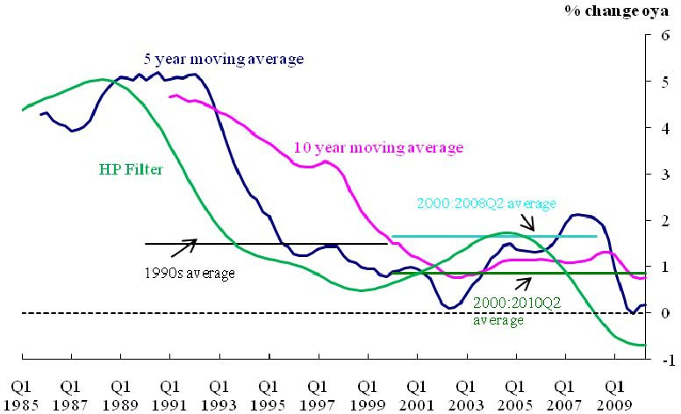

Note: Hodrick Prescott Filter smoothing parameter =1600.

1990s Average = 1.49%, 2000-08Q2 Average = 1.64%, 2000:2010Q2 average = 0.86% Source: Thompson DataStream and Bank calculations

# Figure 2: Simple Measures of potential output: UK

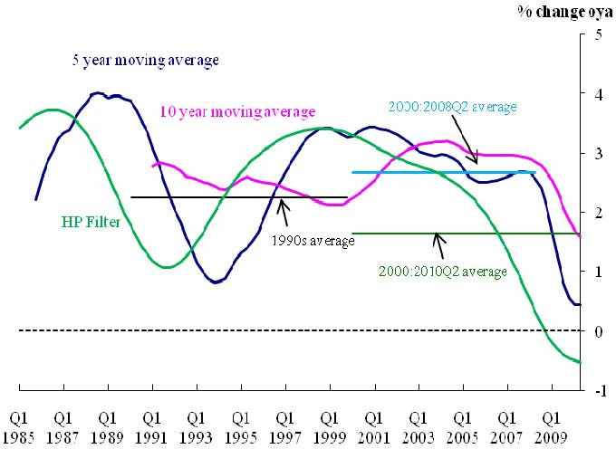

Note: Hodrick Prescott Filter smoothing parameter =1600.

1990s Average = 2.24%, 2000-08Q2 Average = 2.66%, 2000:2010Q2 average = 1.65% Source: Thompson DataStream and Bank calculations

# Figure 3: Investment grade corporate bond spreads

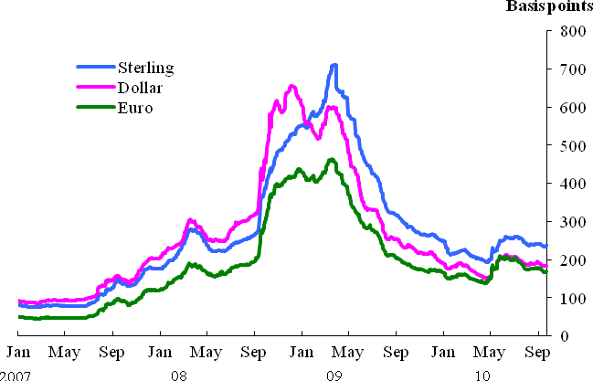

Source: BofA Merrill Lynch Global Research, Bloomberg and Bank calculations

# Figure 4: £ERI Movements

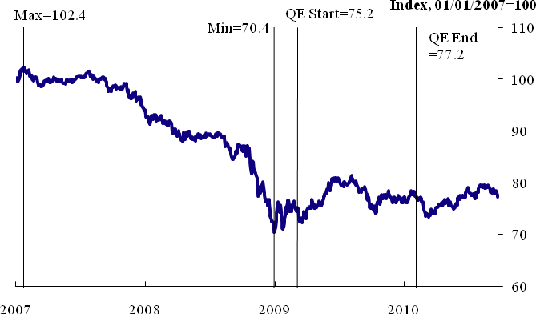

Source: Bank of England

# Figure 5: Spread over Bank Rate of indicative median interest rates on new SME variable- rate facilities (a)

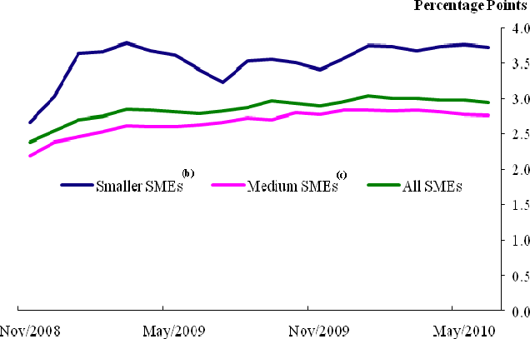

1. Median by value if new SME facilities priced at margins over base rates, by four major lenders. Data cover lending in both sterling and foreign currency, expressed in sterling terms.
2. SMEs with annual bank account debit turnover under £1million.
3. SMEs with annual bank account debit turnover £1 million to £25 million Sources: BBA, BIS, Trends in Lending: August 2010, and Bank calculations

# Figure 6: Lending to small and medium-sized enterprises (a)

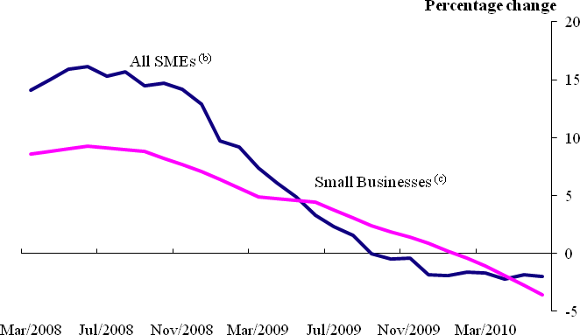

1. Non seasonally adjusted
2. Lending by four major UK lenders to enterprises with annual bank account debit turnover less than £25 million. Data cover lending in both sterling and foreign currency, expressed in sterling terms.
3. Lending by seven major UK lenders to commercial businesses with an annual bank account debit turnover of up to £1 million Sources: BBA, BIS, Trends in Lending: August 2010

# Figure 7: Frequency distribution of CPI inflation based on market interest rate expectations and £200bn asset purchases in the August 2010 Inflation Report (a)

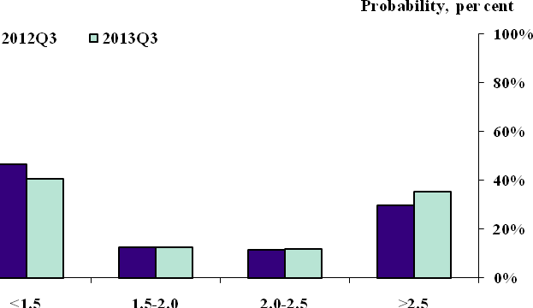

(a) The distribution represents the probabilities that the MPC assigns to CPI inflation lying within a particular range at a specified time in the future.

NB: Values in each bucket (<1.5%, 1.5-2%, 2.0-2.5%, >2.5%) are as follows:

2012 Q3 bars: 47%, 13%, 11%, 29%

2013 Q3 bars: 40%, 13%, 12%, 35%

Source: Bank of England

# Figure 8: UK and Japanese recoveries in context: Real GDP

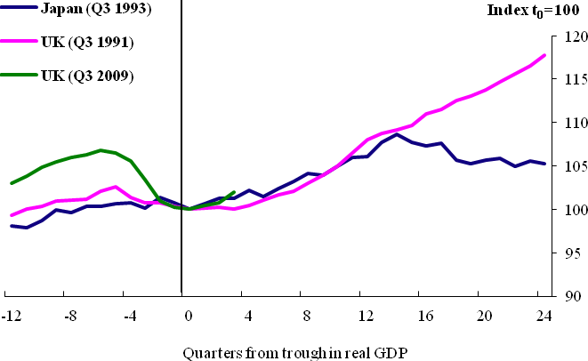

Source: OECD and Bank calculations

# Figure 9: UK and Japanese recoveries in context: Broad Money

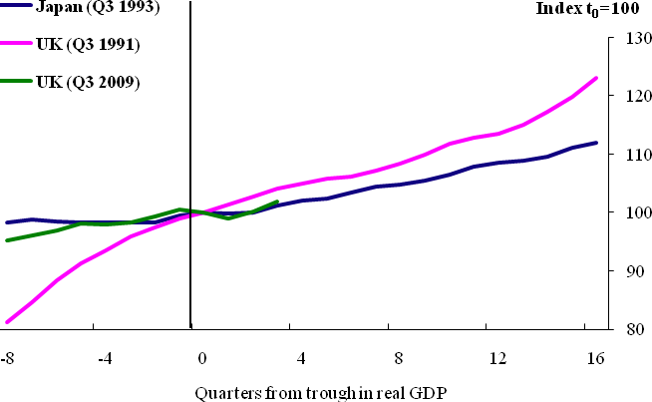

Note: Japanese M2 +CDs, UK 1991 = M4, UK 2009 = M4 ex. Intermediate OFCs Source: Bank of England, Bank of Japan and Bank calculations